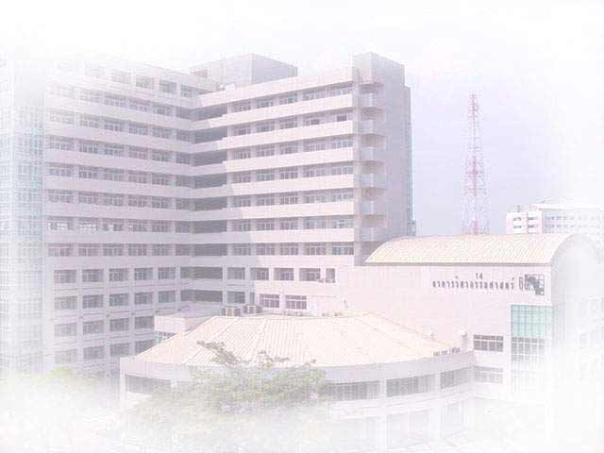

English Program in Civil Engineering
(EP )
Department of Civil Engineering, Faculty of Engineering, Kasetsart University
Major:

1. Structural Engineering (ST)
2. Construction Management (CM)

First Semester 2013 Admission

- Academic Program 2 years 4 semesters (36 Credits)

- Thesis Required

- Class Schedule Saturday 9.00 a.m. – 4.00 p.m.
Sunday 9.00 a.m. – 4.00 p.m.

- Qualifications B.Eng. (Bachelor Degree in Civil Engineering)
or related field

- Expenditure 250,000 Baht (Estimated)

- Application Form Available at the web site and office all year round

- Application Now – May, 2013

- Start of Semester June, 2013

- Office Building 9, Room 9302, Civil Engineering Dept.
Kasetsart University

- Phone/Fax. Tel. 02-579-3171 or Fax. 02-579-3171

- E-mail civilinter@ku.ac.th

- Website http://ceinter.eng.ku.ac.th

- Facbook www.facebook.com/CE.EP.ENG
- For more information, please contact : Miss Arunee Riandara (081-811-5184)
English Program in Civil Engineering
(EP )
Department of Civil Engineering, Faculty of Engineering, Kasetsart University

FIRST SEMESTER, 2013
ADMISSION CALENDAR

SCHEDULES | DATE
- Application Form Download  http://ceinter.eng.ku.ac.th | Now – May, 2013
- Submission of Application Form | Now – 5 May, 2013
- Announcement of Successful Applicants | May, 2013
- Report and Receive Documents for Registration | May, 2013
- Orientation for New Students | May, 2013
- Start of Semester | June, 2013

➢ Contact No: Tel. /Fax. 02-5793171

